## USB Type-C Feature Introduction

**x.1 USB Type-C Summary**

USB Type-C is one kind of high speed interface in Sirius. The USB Type-C receptacle, plug

and cable provide a smaller, thinner and more robust alternative to existing USB interconnects. The Sirius USB Type-C solution targets its use in a variety of platforms ranging from notebooks, PCs, Monitors, down to tablets and smart phones. The mainly external feature of this block is enhances ease of use by being plug-able in either direction between host and device. Besides, DP alternate mode is supported, which means Display port can be combined with USB operation over the same USB Type-C cable. It supports USB3.0 DRD mode, which is GEN1 SS 5.0Gbps; it supports VESA DP v1.2 version, where the maximum link rate is HBR2 5.4Gbps, with lane up to 4, supports HDCPv1.3 and HDCP v2.2 authentication and encryption.

**x.2 Architecture**

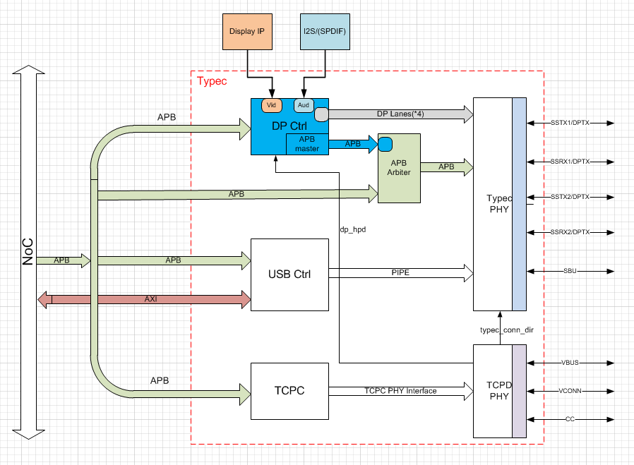

Figure x.1 USB Type-C architecture

It mainly includes five parts: DP controller, USB3.0 controller, Type-C Port controller, Multi-protocol PHY and TCPD PHY.

* DP controller: DP transmitter controller; enabled by Type-C Alternate mode.
* USB3.0 controller: USB3.0 protocol supported; dual role capability that enables connection to external USB devices as either a Host or Peripheral Device.
* Type-C Port controller: received Power Delivery Message from TCPM, then encapsulates and encodes PD message; hardware acceleration for CRC generation/checking; BMC encoding/decoding; Configuration channel(CC) logic.

**x.3 Features description**

* Support DP v1.2 only
  + Maximum support 4 lanes，maximum link rate is 5.4Gpbs
  + Video timing of VIF compiles with CEA-861-F, supported video format are RGB, YCbCr444, YCbCr422 and YCbCr420, supported 6bpc, 8bpc and 10bpc
  + Supported Color Space Conversion(CSC): RGB to YCbCr, YCbCr to RGB, YCbCr422 to YCbCr444 and YCbCr444 to YCbCr422
  + Support I2S interface audio, maximum physical channel is 4
  + Support HDCP v1.3 and HDCP v2.2 authentication and content encrypted
* Support USB3.0 SuperSpeed only
  + USB3.0 PIPE interface compliant
  + USB3.0 U1/U2/U3 support
  + Host Mode is based on xHCI 1.0 protocol, maximum of 64 configurable total slots support, 32 endpoints per slot
  + Up to 15 IN and 15 OUT configurable/programmable endpoints
* Support concurrent mode, where both DP and USB trans at the same time.
* BMC used for USB PD communication over the CC1/CC2 wire.
* Dynamic overcurrent protection on Vbus and Vconn.